**Game Design Document – Bionic Blitz**

**Elevator Pitch**

*Bionic Blitz* is a turn-based strategy game set within a futuristic world (similar to *Blade Runner* or *Cyberpunk 2077)* that combines turn-based strategy gameplay with American football. Players choose from over 30 unique characters of various classes, customize them with equipment pieces, and battle in a series of matches across the world.

|  |  |
| --- | --- |
| **Target Audiences**  * Ages 7-15 * Children and teenagers who like American football. * Turned-based Strategy Game Fans | **Target Platforms**  * iOS and Android |

**Gameplay**

Gameplay consists of players moving on a grid-like battlefield, where they must win by either scoring the most touchdowns (get to the end field, via regular American football) or by defeating all of the enemy players (cause damage to foes by tackling them/attacking similar to games like *X-COM, Fire Emblem, Mario + Rabbids*).

6-10 players per team, depending on the stage – some levels have smaller teams, which changes the strategy for that match.

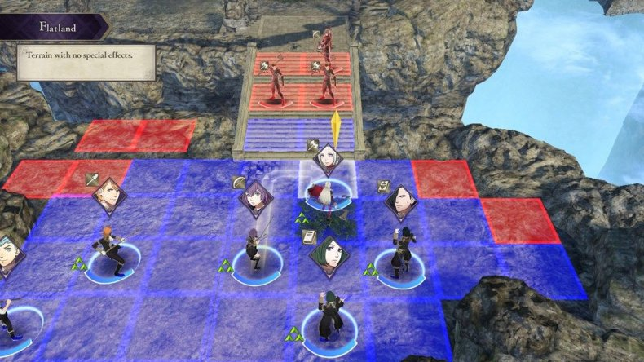

(Gameplay example - *Fire Emblem: Three Houses)*

Players move on a grid-based field. Faster players can move more spaces at once than slower players, with the type of terrain also affecting movement and visibility (players move fewer spaces per turn on sandy terrain, cannot see the entire field on rainy or foggy terrain, etc).

Through the game, the player will encounter new teams – after defeating them, the Star Player of each team will be unlocked, and can be added to the player’s own roster. The player has the ability to customize their team to their liking and can even change around different players’ positions, and change their stats with equipment pieces.

Though mostly a single-player experience, players have the ability to share the player’s character online, so that friends have the ability to add each other’s avatars to their own roster.

**Character Classes**

Create your own character from scratch and start by choosing which class you want them to be. Though there are only three classes, players can upgrade their characters to their liking in order to fit any play style that they wish.

* **Lineman**: High attack & defense stats, but very low speed and endurance. Throw ability is low. Move after other players, and fewer spaces at a time.
* **Running Back/Wide Receiver:** High speed, high agility. Low attack, low defense, average throw. Move before most other players and more spaces at a time.
* **Quarterback:** Balanced class, with stats even across the board. Throwing ability is higher than others.

-Safety/Healer: Safety players are equivalent to Healer classes from classic RPGs. Only allowed 2 healers, so choose them carefully.

**Upgradable Parts**

-Arms & Hands - Improves throw stat (affects both how many spaces a player moves, and whether it can move before other players/enemies) or attack stats.

-Legs & Feet - Improves speed stat.

-Chest, Head/Helmet & Shoulders – Improves attack and defense stats.

**World Overview/Story**

Set within the distant future, where cybernetic enhancements are commonplace, from minor upgrades like metal limbs to complete robotic body modifications, humanity has wholly accepted cybernetic enhancements as the norm.

And alongside this new advancement, American football has grown in popularity on a global level, becoming the biggest game played worldwide. American Football is now the world’s biggest international sport and you (the player) have just been drafted onto America’s new team.

The only problem is that a group run entirely by sentient robots – calling themselves Cybernians – has just been granted permission to participate in this year’s games. Many argue that Cybernians have an unfair advantage, since they are entirely machines. The Cybernians aim to prove once and for all that robots are stronger than humans, with malicious intent to humiliate mankind and take over the world after proving their dominance through sport.

It’s up to the player to train, level up, and upgrade their character alongside other players in order to become the strongest Gridiron football team and defeat the Cybernians.

**Presentation**

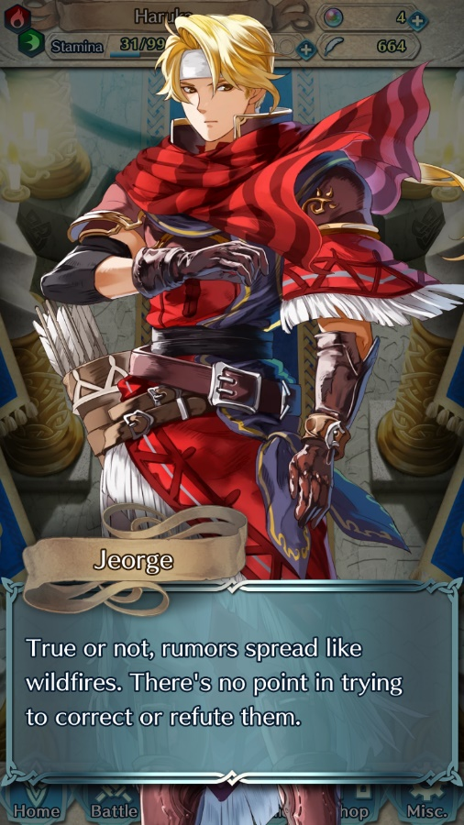

As a mobile game, *Bionic Blitz’s* story will be presented through text and plain images, similar to Fire Emblem. The game will feature high-quality character portraits and written text, and perhaps voice acting.